**Experiment 5**

**Aim**  
Perform Morphological Analysis on a word.

**Theory**

**Morphemes** are considered as smallest meaningful units of language. These morphemes can

either be a root word(play) or affix(-ed). Combination of these morphemes is called

morphological process. So, word "played" is made out of 2 morphemes "play" and "-ed".

Thus finding all parts of a word(morphemes) and thus describing properties of a word is

called "Morphological Analysis". For example, "played" has information verb "play" and

"past tense", so given word is past tense form of verb "play".

A morphological analyzer is a program that analyzes the morphology of an input word. It

uses rules to identify the root and grammatical features of given words. It splits a given word

into it's root, lexical category, gender, number, person, case, case marker or tense aspect

modality(TAM), suffix and other required grammatical features as given below.

1. root : Root of the word (e.g. ladZake word has root ladZakA)

2. cat : Category of the word (e.g. Noun=n, Pronoun=pn, Adjective=adj, verb=v, adverb=adv

post-position=psp and avvya=avy)

3. gen : Gender of the word

4. num : Number of the word (e.g. Singular=sg, Plural=pl, dual, and

any )

5. per : Person of the word (e.g. 1st Person=1, 2nd Person=2, 3rd Person=3, and any)

6. case : Case of the word (e.g. direct=d, oblique=o and any)

7. tam : Case marker for noun or Tense Aspect Mood(TAM) for verb of the word

8. suff : Suffix of the word

**Analysis of a word**

बच्चों (bachchoM) = बच्चा (bachchaa) (root) + ओं (oM) (suffix)

(ओं=3 plural oblique)

A linguistic paradigm is the complete set of variants of a given lexeme. These variants can be

classified according to shared inflectional categories (eg: number, case etc) and arranged into

tables.

**Paradigm for बच्चा**

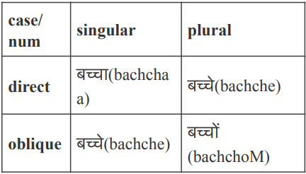

**Algorithm to get बच्चों (bachchoM) from बच्चा (bachchaa)**

1. Take Root बच्च (bachch) आ (aa)

2. Delete आ (aa)

3. output बच्च (bachch)

4. Add ओं (oM) to output

5. Return बच्चों (bachchoM)

Therefore, आ is deleted and ओं is added to get बच्चों

**Add-Delete table for बच्चा**

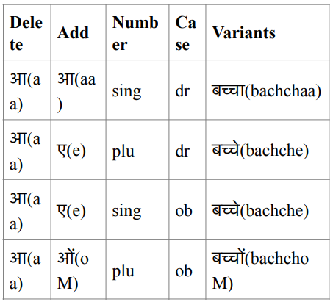

**Paradigm Class**

Words in the same paradigm class behave similarly, for Example लड़क is in the same

paradigm class as बच्च, so लड़का would behave similarly as बच्चा as they share the same

paradigm class.

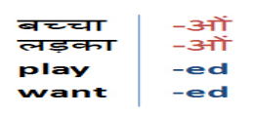

Words can be analyzed morphologically if we know all variants of a given root word. We can

use an 'Add-Delete' table for this analysis.

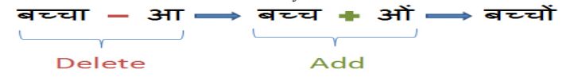

**Code**

import codecs

import re

# read the input file

filepath = "input.txt"

f = codecs.open(filepath, *encoding*="utf-8")

text = f.read()

sentences = text.split(u"।")  # since hindi sentences end with '|'

words_list = list()

for sentence in sentences:

    words = sentence.split(" ")  # words are seperated by a space in hindi

    words_list += words

suffixes = {

    1: [

        u"ाएगी",

        u"ाएगा",

        u"ाओगी",

        u"ाओगे",

        u"एंगी",

        u"ेंगी",

        u"एंगे",

        u"ेंगे",

        u"ूंगी",

        u"ूंगा",

        u"ातीं",

        u"नाओं",

        u"नाएं",

        u"ताओं",

        u"ताएं",

        u"ियाँ",

        u"ियों",

        u"ियां",

    ],

    2: [u"ो", u"े", u"ू", u"ु", u"ीय", u"ि", u"ा"],

    3: [u"कर", u"ाओ", u"िए", u"ाई", u"ाए", u"ने", u"नी", u"ना", u"ते", u"ीं", u"ती", u"ता", u"ाँ", u"ां", u"ों", u"ें"],

    4: [

        u"ाकर",

        u"ाइए",

        u"ाईं",

        u"ाया",

        u"ेगी",

        u"ेगा",

        u"ोगी",

        u"ोगे",

        u"ाने",

        u"ाना",

        u"ाते",

        u"ाती",

        u"ाता",

        u"तीं",

        u"ाओं",

        u"ाएं",

        u"ुओं",

        u"ुएं",

        u"ुआं",

    ],

    5: [u"ाएंगी", u"ाएंगे", u"ाऊंगी", u"ाऊंगा", u"ाइयाँ", u"ाइयों", u"ाइयां"],

}

stems = list()

for word in words_list:

    for L in range(1, 5):

        if len(word) >= L + 1:

            for suffix in suffixes[L]:

                if word.endswith(suffix):

                    word = word[:-L]  # stripping the suffix from the word

                    try:

                        if word[-1] == u"ि":

                            word = word[:-1] + u"ी"

                    except:

                        print(word)

    if word:

        stems.append(word)

filename = "stems_generated.txt"

f = codecs.open(filename, "w", *encoding*="utf-8")  # open in write mode

for stem in stems:

    f.write(str(stem))

    f.write(u"\u0020")

f.close()

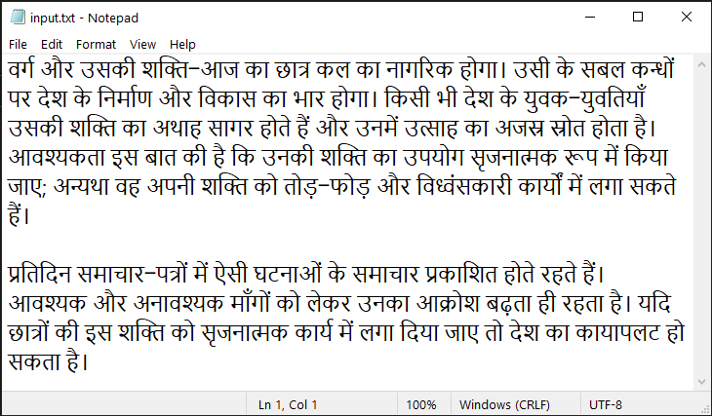

**Output**

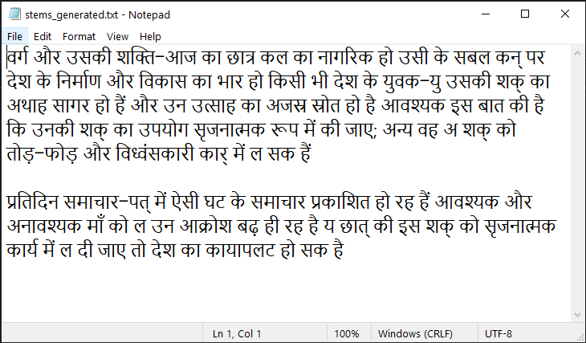

**Conclusion**

Hence, we have successfully performed morphological analysis on a Hindi text.